the past years, banks have virtually stopped giving investors “interest-only” loans on Australian property, and have been insisting on buyers making regular principle repayments. This has led many investors to become confused, and unsure whether an investment property still makes sense with this type of repayment.

2

What if you cannot get an interest only loan?

This special chapter examines:

Interest-only vs. principle repayment loans: positives and negatives.
1

2 How to pay 3.73% interest on a 6%
interest rate loan.

When is a repayment loan
3
actually better than an interest-only loan?

3
3

What if you cannot get an interest only loan?
The Australian banks in recent years have cracked down on interest-only loans, and many investors feel deprived! However, all is not lost if you are building a portfolio!

In the last 7 to 10 years there has been a huge trend by investors to move away from repaying capital and only paying the interest on a loan.

The investment concept behind interest-only loans is quite simple:

Simply, as explained elsewhere in this book:

The interest is fully tax deductible so you can maximise your interest payments and get the highest possible tax benefits.
1
2

It is better for cash flow.

Let’s explore the options in case you are unable to get an interest only loan but you still want to build your property portfolio.

FIRSTLY LET’S LOOK AT
CASH FLOW

In simple terms if you have a 6% interest- only loan on a $322,000 dollar mortgage which was used to buy a property for
$460,000 the interest figure per annum is
$19,320. (322,000 x 6%) Could not be simpler.

In monthly terms it is $1,610 per month.

With rent of 5% return such as available in Brisbane (Melbourne and Sydney will be less) you are getting $23,000 per annum (or
$1,917 per month).

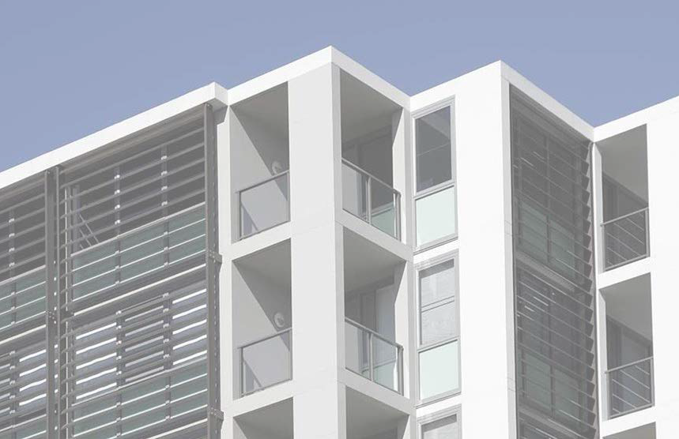

So you can clearly see that the rent is covering the whole of the bank interest, with a bit of surplus to help with other expenses.

But if you take a principal and interest loan over (say) 25 years the total bank repayment is $24,896 per annum
(or $2,074 pm at the same interest rate of 6%)

So, clearly you are paying $464 dollars more per month on the principal and interest loan.

Not a huge amount, about 15 bucks a day, so it is unlikely to be a deal killer for most people.

6
6

N

But for those building a portfolio of
properties, this CAN make a difference if
you have 3,4,5 or even 6 or more properties, especially if they are higher priced properties

But for many investors, who have just one or
possibly two properties, or those just starting their portfolio, it is crucial to understand the following.

7
7

INTRODUC TIO N

THERE ARE 3 CRITICAL
PIECES OF INFORMATION YOU SHOULD KNOW.

The first is this
A fixed-rate mortgage amortizes over the loan’s repayment period, meaning the proportion of interest paid vs. principal repaid changes each month while the total monthly payment stays the same. As the loan amortizes, the amount of monthly interest paid decreases while the amount of principal paid increases

The second is this.
Making principle payments greatly reduces the total interest you pay.

MEANING in fact your 6% interest rate is actually just 3.73%! (See below)

All for $15 a day!

INTRODUC TIO N

FUL LY MAXIMISE YOUR TAX CREDITS IS THE
OTHER POINT MENTIONED

This is true. But did you know that when you take a principal and interest loan actually you are paying mostly interest in the early years anyway? Most people are just simply not aware of this. So in many ways it is just like an interest-only loan.

YEAR ONE:

interest-only: $1,610 per month

P and I loan: interest $1,597 per month

Just $13 a month for tax credits. At 32.5% tax rate that means you are getting just $4.22 per month extra benefit.

YEAR TWO:

interest-only: $1,610 per month

P and I loan: interest $1,567 per month!

P R I N C I P L E A N D I N T E R E S T P A Y M E N T S

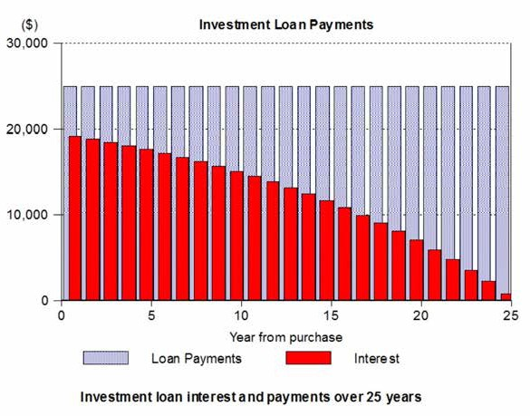

So you’re still getting nearly all the same tax credits available so it is far from all bad!

<But here is a critical point to consider: that extra money you are paying can effectively be called “savings” because you are using that every month to reduce the amount of your debt to the bank, which then also reduces the total interest you pay>

I N V E S T M E N T L O A N ( I N T E R E S T O N L Y ) P A Y M E N T S

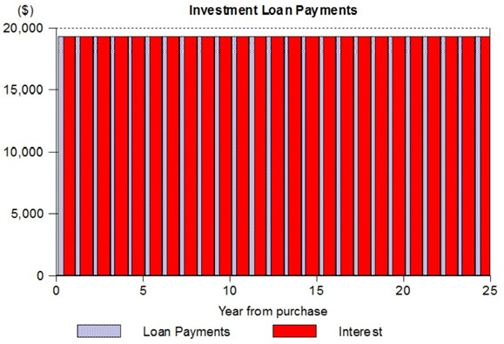

NOW THIS IS IMPORTANT:

Let’s compare how much interest you will pay.

If paying interest-only over 25 years you pay a total $483,000 in interest.
At 5% appreciation in the property value you sell for $1.567 million. Hard to believe but it often happens.

Repay the loan of $322,000 and Voila! You have
$1.245 million left. You have "magically " turned your initial deposit of $138K into $1.245 million.

INVESTMEN T PROPER T Y V ALU E & DEB T

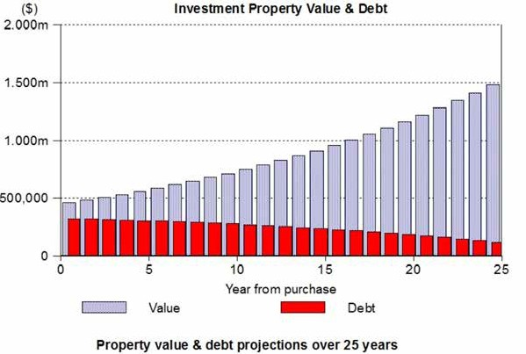

On the principle and interest loan you have repaid the whole principle so you are left with the full $1.567million in your hand.

AND…

You paid a TOTAL of only $300,396 in interest.

A cash saving of $183,000 in interest!
If interest-only the whole term it would have been an effective rate of paying 3.73% pa. ($300,396/25 years=$12,016 pa /322,000= 3.73%)

CONCLUSION

While interest only loans are preferred to help with cash flow when buying many properties, principle loans are also an excellent way for most to purchase one or two properties as you also get the most tax benefits when you need them in the early years, you are reducing the debt steadily, getting equity build up, meaning you can refinance more quickly to buy another property, and overall you save a huge amount of interest over the long term, potentially lowering significantly your interest rate as shown earlier.

They are NOT so good when:

You are buying a number of properties,
- unless you can manage the cash flow.

You are buying higher price properties,
- unless you can manage the cash flow.
You are over 60 years old, as many banks
- have an age limit around 75 years, as you will usually want to get a 20 year loan, unless you can manage the cash flow.

14

15

